**RESEARCH PAPER ON PRODUCT MONITORING AND REPUTATION MANAGEMENT**

**NIHAL KUMAR G**

FINAL YEAR STUDENT (UG),

DEPARTMENT OF CSE

SATHYABAMA INSTITUTE OF SCIENCE AND TECHNOLOGY

nihalkumar2322003@gmail.com

**SETHURAMALINGAM G**

FINAL YEAR STUDENT (UG),

DEPARTMENT OF CSE

SATHYABAMA INSTITUTE OF SCIENCE AND TECHNOLOGY

sethu8g@gmail.com

**Ms. BALASAI GAYATHRI**

ASSISTANT PROFESSOR,

DEPARTMENT OF CSE

SATHYABAMA INSTITUE OF SCIENCE AND TECHNOLOGY

balasaigayatri.cse@sathyabama.ac.in

**ABSTRACT:**

This research paper investigates a mutually beneficial partnership between product monitoring and managing one's reputation in the setting of the contemporary digital marketplace. The study begins by elucidating the changing terrain of consumer interactions and the profound the influence of internet reviews and social media on brand perception. Through a comprehensive literature review, the paper explores the nuanced dimensions of product monitoring, emphasizing the role it plays in ensuring quality assurance and customer satisfaction. Some businesses, motivated by the desire to make money, may create spam reviews about other products or their own, potentially misleading consumers into making purchases unworthy product. Sentiment analysis has emerged as one of text analysis's most fascinating topics due to its possible business advantages. The findings of this study illuminated the challenges and opportunities associated with product monitoring and reputation management in various industries.

**INTRODUCTION:**

Businesses must navigate a challenging environment where product quality and brand reputation are closely related as consumers use online platforms more and more to investigate, assess, and discuss their experiences. This research paper explores the pivotal domains of product monitoring and reputation management, illuminating their significance in the era of digital and proposing a comprehensive framework for businesses to effectively navigate these crucial aspects. The objective is to retain a favourable reputation while resolving any issues that may emerge. Reputation management encompasses a range of strategies to improve public opinion, manage internet content, and efficiently address unfavourable events or media coverage that may impact an organization's image. Product quality directly impacts brand perception, customer loyalty, and market share. Conversely, a company's reputation can significantly influence consumer trust, investor confidence, and stakeholder relationships. Therefore, effective product monitoring and reputation management have emerged as essential components of modern business strategy.

**ARCHITECTURE DIAGRAM:**

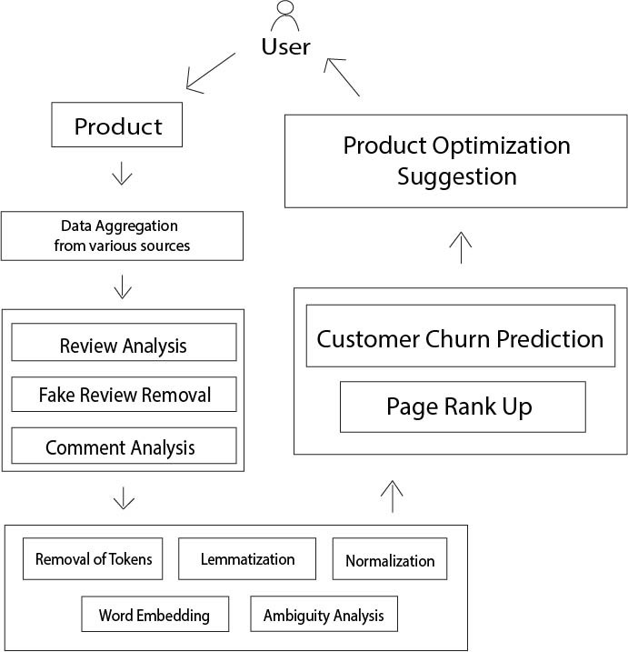

**PRODUCT MONITORING:**

Product monitoring software, which manages the product lifecycle and streamlines the difficult, tedious, and tedious process of monitoring, reviews, and reporting for growth, governance, and compliance, is a game-changer for product leaders. Product governance and compliance: Historically, this has required a great deal of time-consuming, manual monitoring and review that is not scalable.

**REPUTATION MANAGEMENT:**

It is the art of moulding public opinion of your business or brand. Three fundamental components comprise a brand's reputation: the perceptions of others, the company's performance and operations, and the messaging the brand conveys about itself. Maintaining a robust brand image entails keeping an eye on what people are saying and thinking about the company, reacting to false information, malicious accusations, and unfavourable reviews, and generally keeping an eye out for and seizing opportunities to improve the company's reputation. Management of a company's reputation is rarely owned by one individual or division.

**METHODOLOGY:**

Methodologies for product monitoring and reputation management involve systematic approaches and frameworks to ensure the quality of products and maintain a positive brand image.

**NATURAL LANGUAGE PROCESSING:**

One area of artificial intelligence (AI) is called natural language processing (NLP), which focuses on the interaction between computers and human language. It comprises developing models and methods that enable computers to comprehend, interpret, and produce meaningful, contextually appropriate human language. NLP includes a broad range of activities, such text analysis, sentiment analysis and language translation, and speech recognition. The challenges in NLP lie in dealing with the intricacies of language, including context, ambiguity, and cultural nuances. Ongoing research and innovations in machine learning and deep learning techniques continue to propel the capabilities of NLP, making it an integral component of modern AI systems and shaping the way we interact with technology.

**RANDOM FOREST ALGORITHM:**

It is a learning algorithm widely used in machine learning for classification and regression tasks. It operates by constructing a multitude of decision trees during training and outputs the mode (classification) or mean prediction (regression) of the individual trees. The "random" in Random Forest stems from two key sources of variability introduced in the tree-building process. The final prediction is an aggregation of the predictions made by individual trees. Random Forest is robust, resistant to overfitting, and effective in handling high-dimensional datasets. Its versatility, scalability, and ability to capture complex relationships make it a popular choice in various domains, from finance and healthcare to image recognition and bioinformatics.

**DERIVATION AND EQUATION:**

The formula for calculating the feature importance is: 

To understand this formula, first, let’s plot the decision tree for the above dataset:

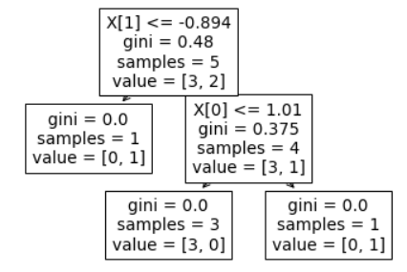

Here we have two columns [0 and 1], to compute the significance of each attribute in [0] we need to find those nodes where the split happened due to this column [0]. In this dataset, we have only 1 node for column [0] and column [1]. Out of all the nodes, we will find the feature importance of those nodes where the split happened due to column [0] and then divide it by the significance of the trait of all the nodes. To calculate the importance of a node we will use this formula:

Our Ntis 5, N is 5, impurity of that node is 0.48, Nt(right) is 4, right impurity is 0.375, Nt(Left) is 1, and left impurity is 0, putting all this information in the above formula we get:

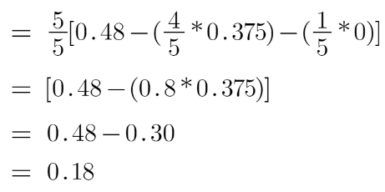

Similarly, we will calculate this for 2nd node:

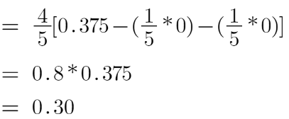

Now let’s calculate the importance of features [0] and [1], This can be calculated as:

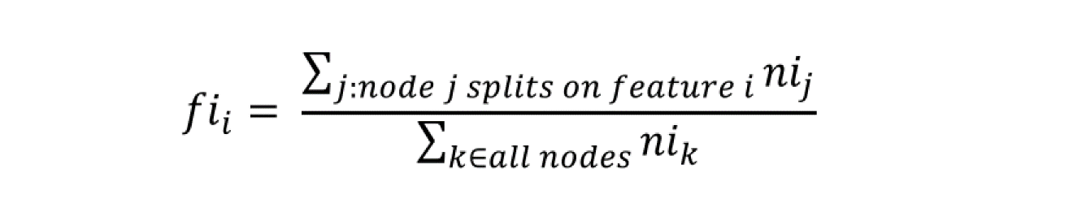

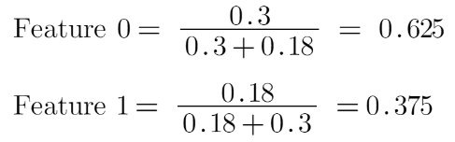

Hence for the feature [0], the significance of the trait is 0.625 and for [1] it is 0.375.

**PAGE RANK ALGORITHM:**

PageRank is a pivotal algorithm within the domain of search engine optimization and web ranking, initially introduced by Google's co-founders. The algorithm's fundamental principle revolves around assessing the significance of web pages according to the structure of the hyperlink graph. In essence, PageRank interprets a link from page A to page B as a vote of confidence from page A to page B. However, not all votes are equal, as the significance of the page casting the vote contributes to the weight of the vote. Pages with higher PageRank scores pass on more authority to pages they link to. The iterative nature of the algorithm involves calculating PageRank scores for every page according to the scores of pages linking to it, creating a dynamic and recursive process

**DERIVATION AND EQUATION:**

**SIMPLE RECURSIVE FORMULATION:**

The vote for each link is based on how important the source page. If page J with importance rj has n out-links, each link gets ${rj}/n$ votes. Pages j’s own importance is the sum of the votes on its in-links.

rj = +

**Page rank -The Flow Model:**

A vote from an important page is worth more and defines a “rank” rj for page j.

rj =

di out-degree of note I,

Flow equation:

ry =

ra =+ rm

rm =

Additional constraints forces uniqueness:

Ry + ra + rm = 1

Solution:

ry = , ra = , rm =

**CUSTOMER CHURN PREDICTION:**

It is a critical aspect of business analytics that involves the application of sophisticated data analysis and key methods for machine learning to forecast the likelihood of customers discontinuing their relationship with a company. In a very competitive business environment, keeping clients is paramount, making churn prediction a strategic imperative for companies across various industries. In-depth exploration of forecasting customer attrition would encompass various methodologies, model evaluation techniques, real-world case studies, and the ethical considerations of using predictive models. The comprehensive analysis would contribute to a nuanced understanding of customer churn dynamics, providing actionable insights for businesses to foster customer retention and sustainable growth.

**RESULT AND OUTPUT:**

In this paper, we cover the needs of new and uprising entrepreneurs by creating a website with all-in-one features for reviewing datasets and visualizing numerous data. There is also customer churn prediction for identifying trends in purchases and decrypting patterns for customer retention helps in making business prosperous. Page rank helps get a better understanding of the business standing among various competitors and suggestions improvise business strategies enabling a better position. Entrepreneur are able to get the bigger picture of the workflow and know the dos and don’ts in the business.

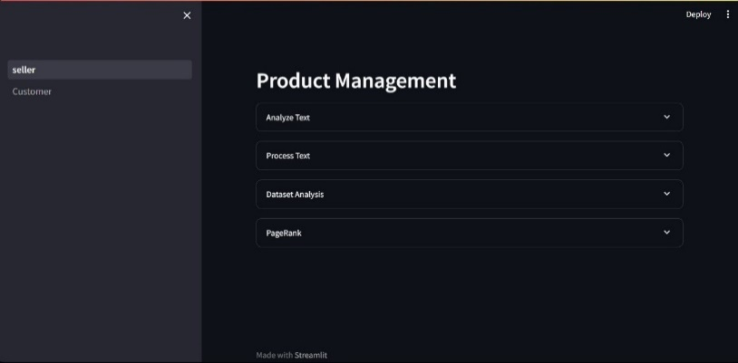

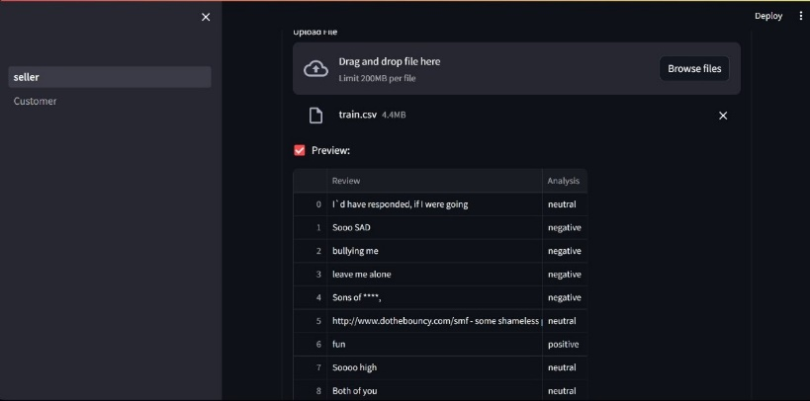

**CONCLUSION:**

In conclusion, the research paper on Product Monitoring and Reputation Management provides a comprehensive exploration of these two interconnected pillars of contemporary business strategy. Through an in-depth analysis of product monitoring methodologies and reputation management practices, the paper underscores their collective impact on organizational success. The Product Monitoring section emphasizes the significance of instantaneous data analysis, quality control measures, and supply chain optimization in ensuring product quality and adherence to industry standards.

**REFERENCE:**

Online Reputation Management in the era of social media: A Review and Research Agenda by International Journal of Electronic Commerce (2023).

A. Sinha, N. Arora, S. Singh, M. Cheema, and A. Nazir, “Fake Product Review Monitoring Using Opinion Mining,” 2018.

McCallum, Andrew. "Graphical Models, Lecture2: Bayesian Network Representation" (PDF). Retrieved 22 October 2019.

M. H. Annaby, Y. M. Fouda, and M. A. Rushdi, ‘‘Improved normalized cross-correlation for defect detection in printed-circuit boards,’’ IEEE Trans. Semicond. Manuf., vol. 32, no. 2, pp. 199–211, May 2019.

The Role of Artificial Intelligence in Online Reputation Management: A Review by Journal of Public Relations Research (2023).

The Impact of Online Reputation on Consumer Purchase Decisions: A Review of the Literature by Frontiers in Psychology (2022).